Question1:

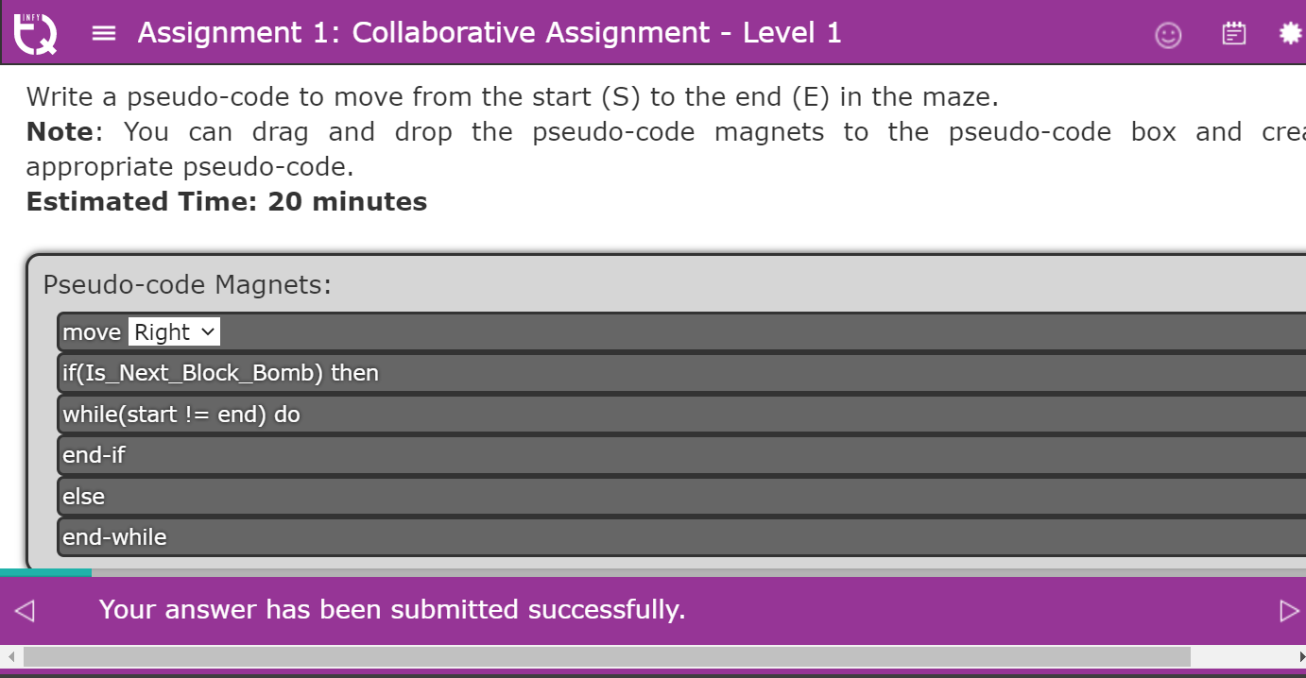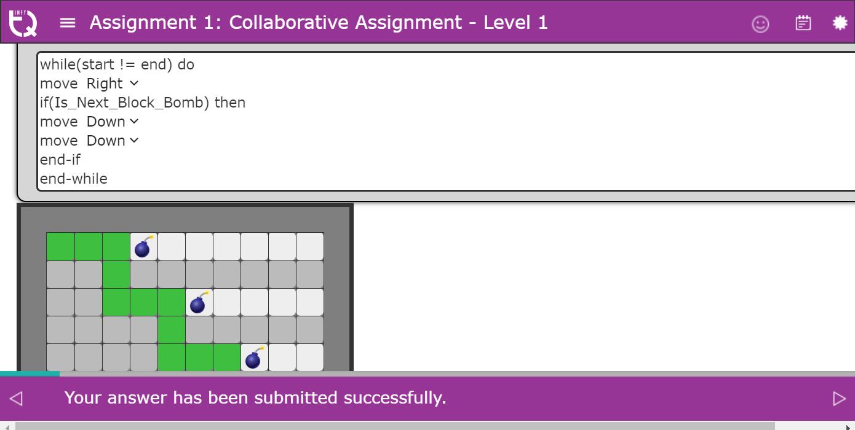



Question2:

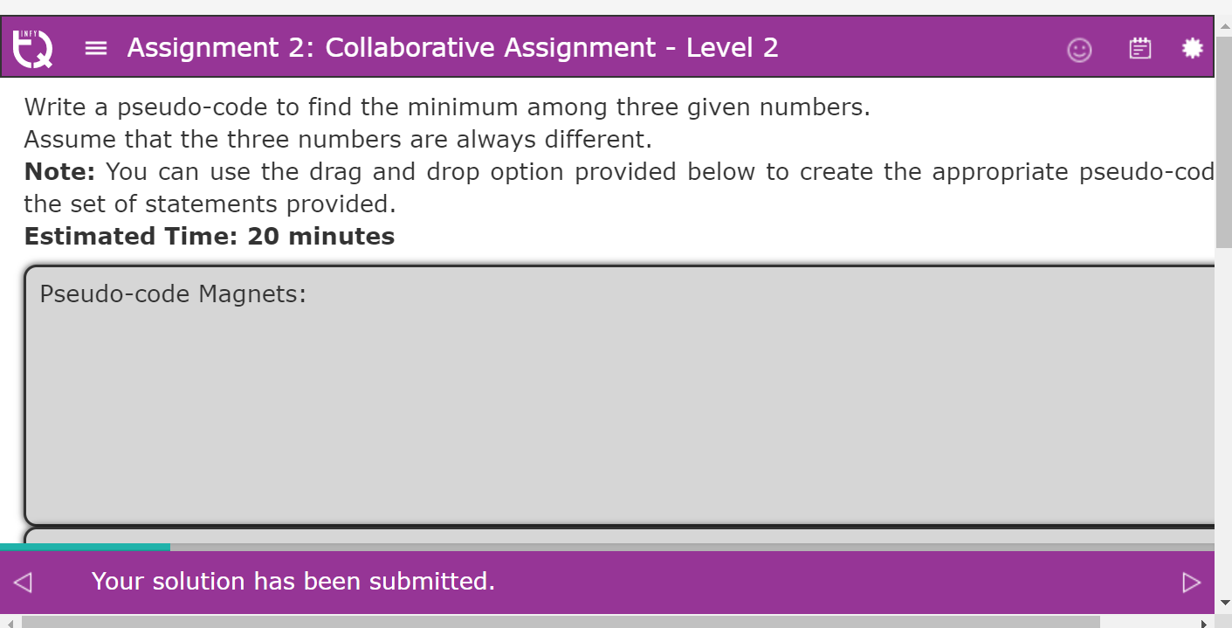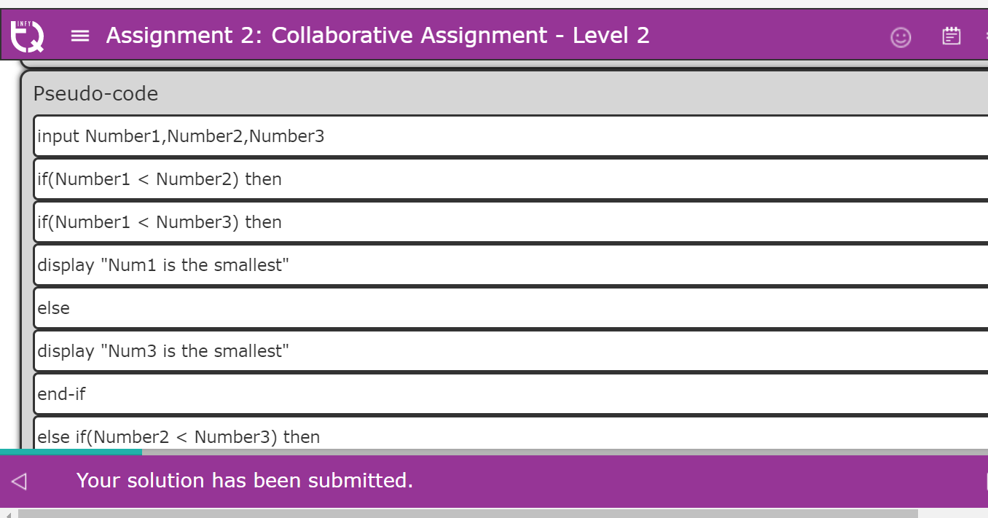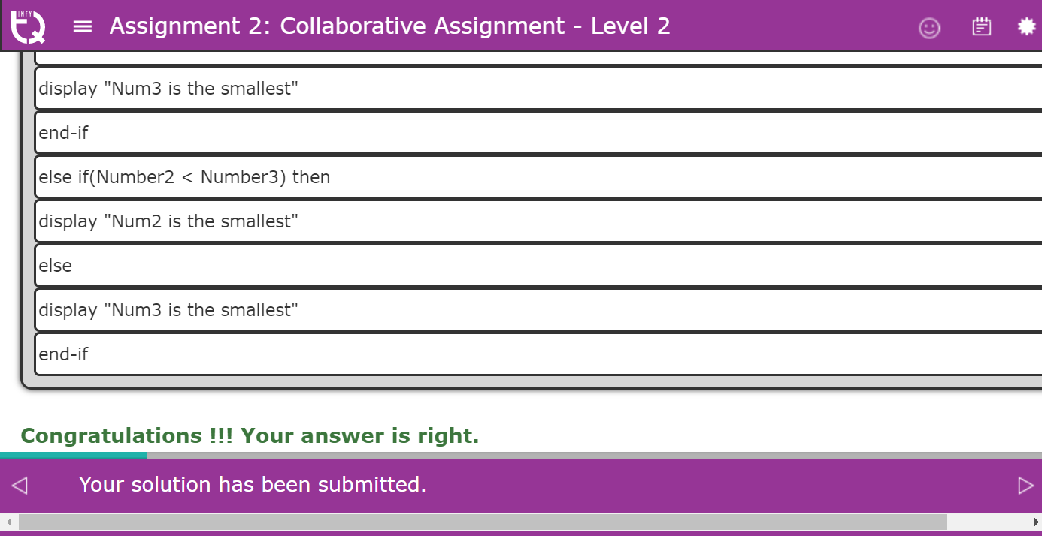

Question 3:

Jack and his three friends have decided to go for a trip by sharing the expenses of the fuel equally.  
Write a Python program to calculate the amount (in Rs) each of them need to put in for the complete (both to and fro) journey.  
The program should also display True, if the amount to be paid by each person is divisible by 5, otherwise it should display False. (**Hint**: Use the relational operators in print statement.)  
Assume that mileage of the vehicle, amount per litre of fuel and distance for one way are given.

Test your code by using the given sample inputs.  
Verify your code by using the **2nd** sample input(highlighted) given below:

|  |  |  |  |
| --- | --- | --- | --- |
| **Sample Input** | | | **Expected Output** |
| Mileage of the vehicle (km/litre of fuel) | Amount per litre of fuel (Rs) | Distance for one way (kms) |  |
| 12 | 65 | 96 | 260.0 True |
| 12 | 40 | 190 |  |

**Note:** You have to always submit your assignments/exercises!!  
  
**Estimated time: 30 minutes**

Answer 3

#PF-Assgn-3

#This verification is based on string match.

mileage=12

amount_per_litre=40

distance_one_way=190

per_head_cost=0

divisible_by_five=False

#Start writing your code from here

#Populate the variables: per_head_cost and divisible_by_five

per_head_cost=distance_one_way*2/ mileage * amount_per_litre / 4

if per_head_cost % 5 ==0 :

divisible_by_five = True

else:

divisible_by_five = False

#Do not modify the below print statements for verification to work

print(per_head_cost)

print(divisible_by_five)

Question 4

Write a Python program to calculate and display the interest on a loan amount (Rupees) using the formula:  
  
interest=(principal * rate of interest * time)/100  
  
Test your code by using the given sample inputs.  
Verify your code by using the **2nd** sample input(highlighted) given below:

|  |  |  |  |
| --- | --- | --- | --- |
| **Sample Input** | | | **Expected Output** |
| Principal | Rate of Interest | Time |  |
| 20000 | 5 | 10 | 10000.0 |
| 7800 | 7.7 | 26 |  |

**Note:** You have to always submit your assignments/exercises!!  
  
**Estimated time: 15 minutes**

#PF-Assgn-4

#This verification is based on string match.

principal=2000

rate_of_interest=5

time=5

interest=0

#Start writing your code from here

#Populate the variable: interest

interest=(principal*rate_of_interest*time)/100

#Do not modify the below print statement for verification to work

print(interest)

Question 5

Write a pseudo-code to find out if a given year is a leap year or not.20 min  
Any year which is divisible by 4 and not by 100 are leap years. Otherwise, any year which is divisible by 400 is also a leap year.  
Use the drag and drop option provided to create the correct pseudo-code.  
  
**Note:** This page has system assisted problem solving. Interactions would come to your help if you wait at any step or if you make a mistake.  
We encourage you to try different logic variations.

I have understood the problem, Write a pseudo-code to find out if a given year is a leap year or not.20 min  
Any year which is divisible by 4 and not by 100 are leap years. Otherwise, any year which is divisible by 400 is also a leap year.  
Use the drag and drop option provided to create the correct pseudo-code.  
**Note:** This page has system assisted problem solving. Interactions would come to your help if you wait at any step or if you make a mistake.  
We encourage you to try different logic variations.

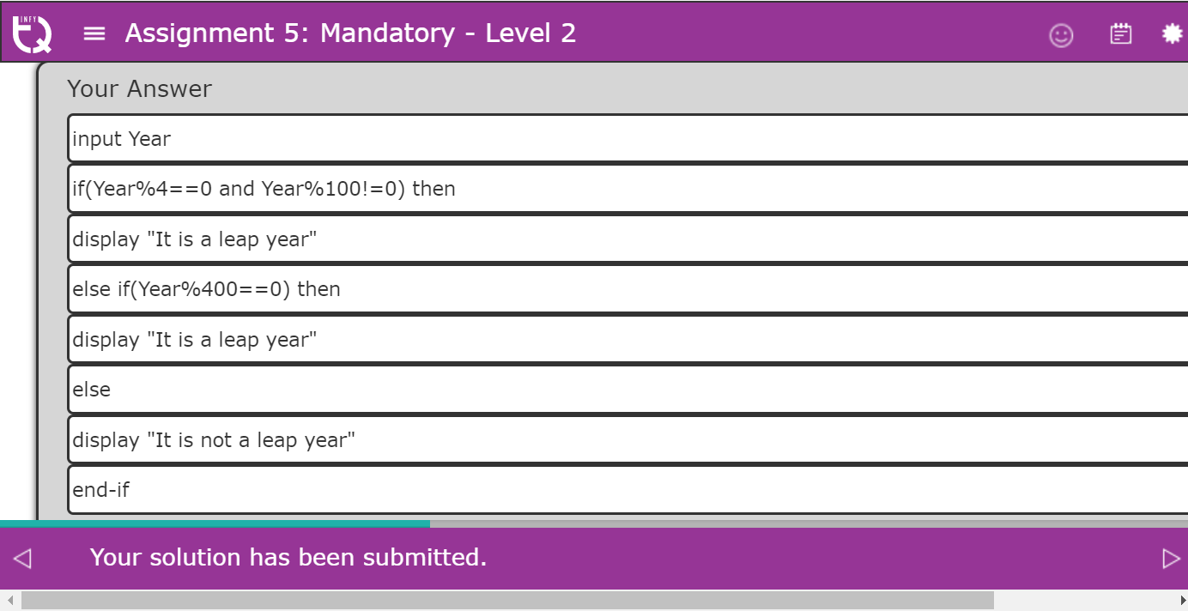

Question 6

Write a pseudo-code to check whether a given number is a palindrome.  
Examples of palindrome: 121, 1331, 2332,78900987,123456654321 etc.  
**Note:** You can use the drag and drop option provided below to create the appropriate pseudo-code from the set of statements provided

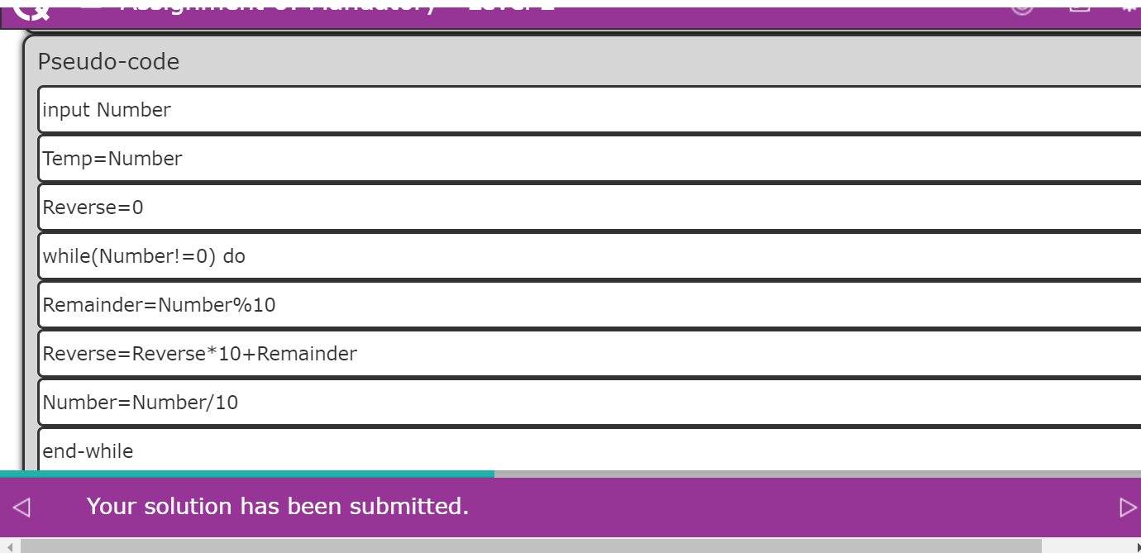

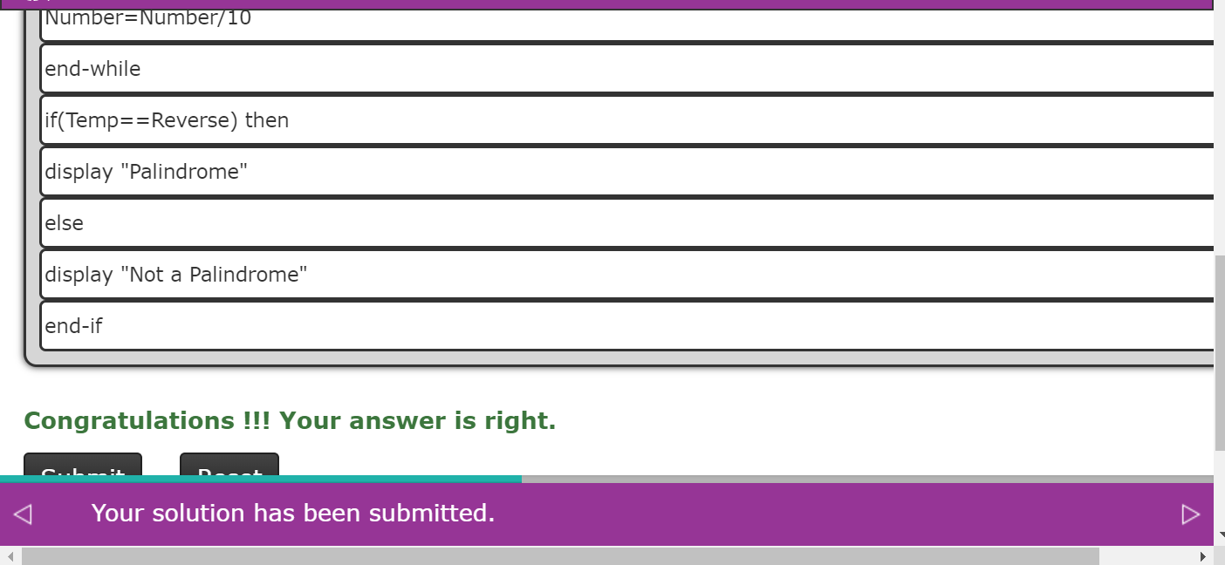

Question 7

Write a pseudo-code to find the sum of numbers divisible by 4.The pseudo-code must allow the user to accept a number and add it to the sum if it is divisible by 4. It should continue accepting numbers as long as the user wants to provide an input and should display the final sum.  
**Note**: You can drag and drop the pseudo-code magnets to the pseudo-code step boxes and create the appropriate pseudo-code.  
**Estimated Time: 20 minutes**

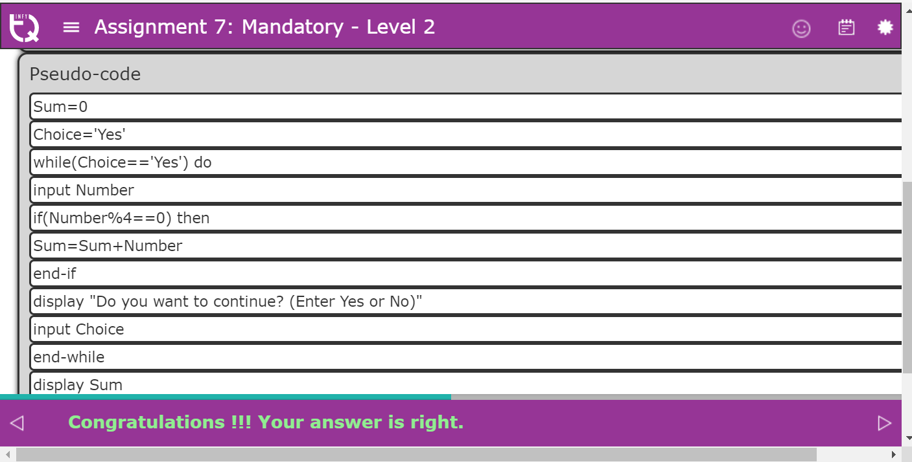

Question 8

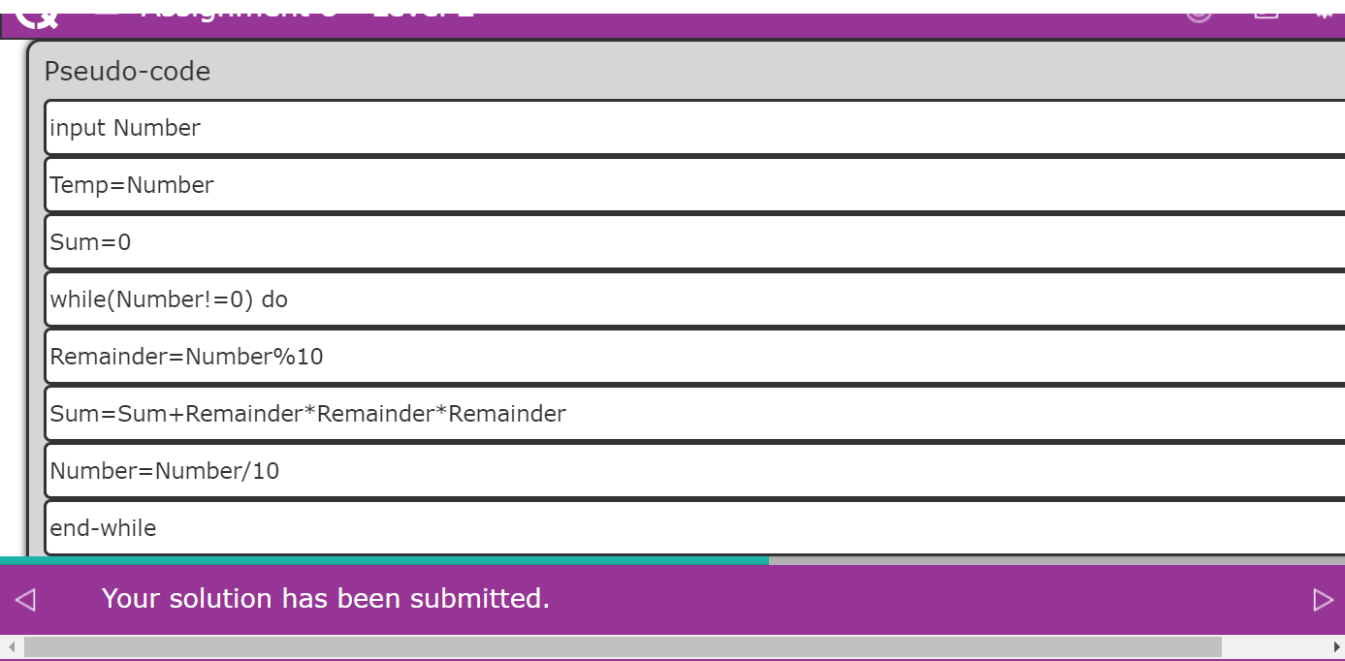

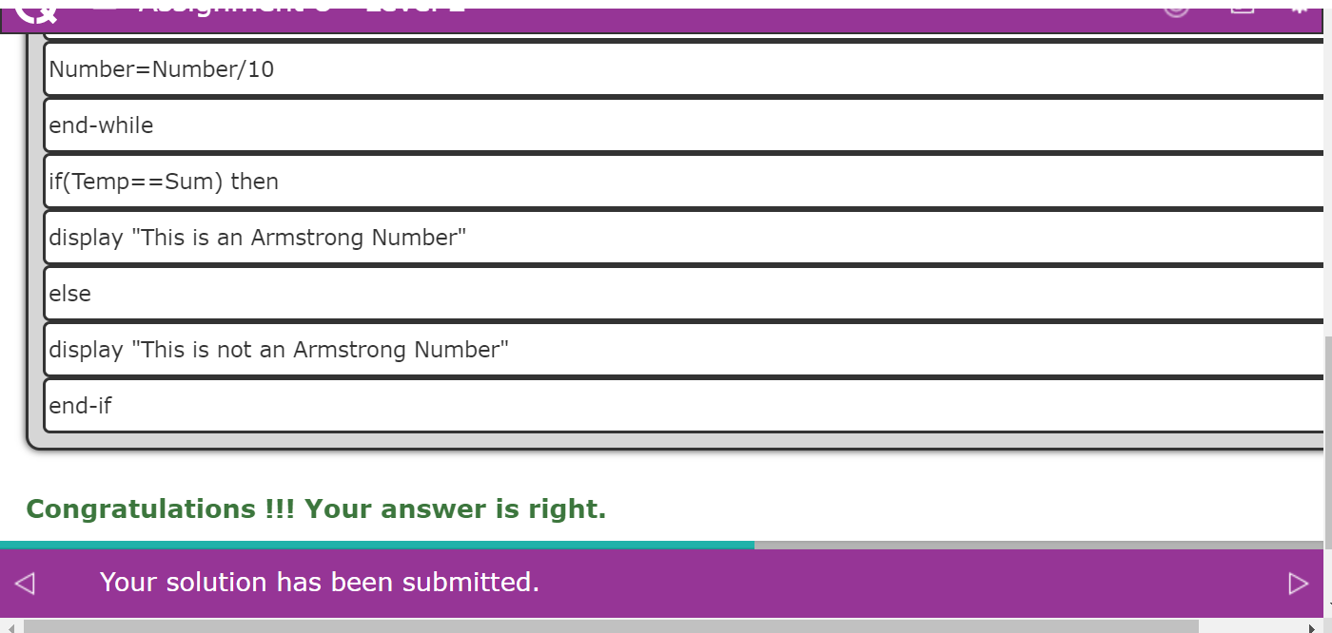

Question 9

Write a pseudo-code which helps ( O> ) to reach ( E ).

Note: You can drag and drop the pseudo-code magnets to the pseudo-code box and create the appropriate pseudo-code.

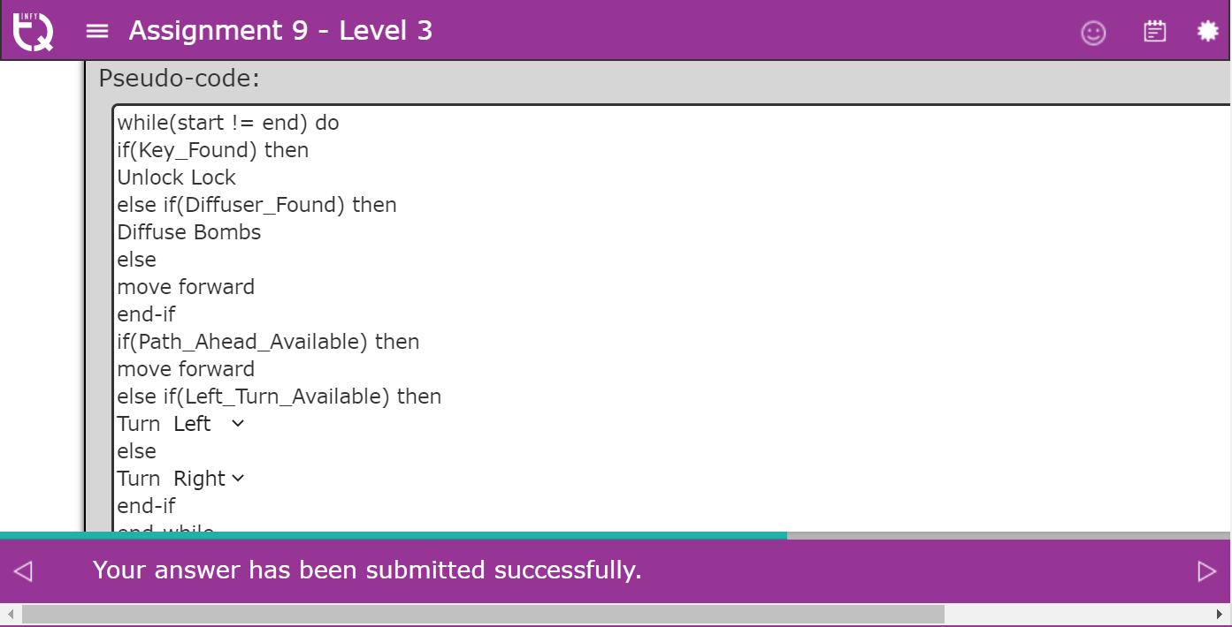

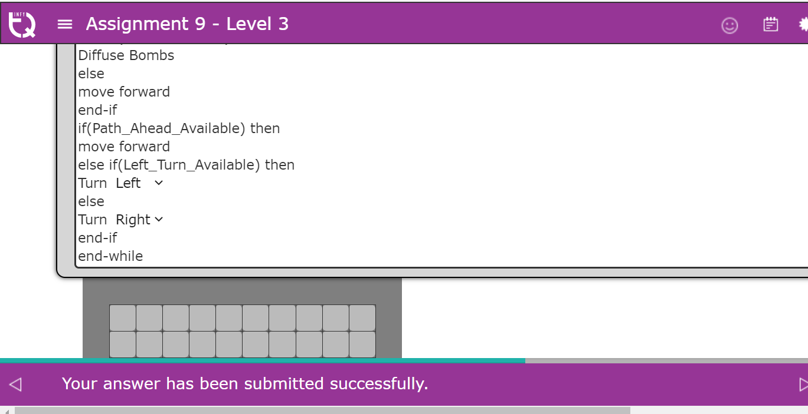

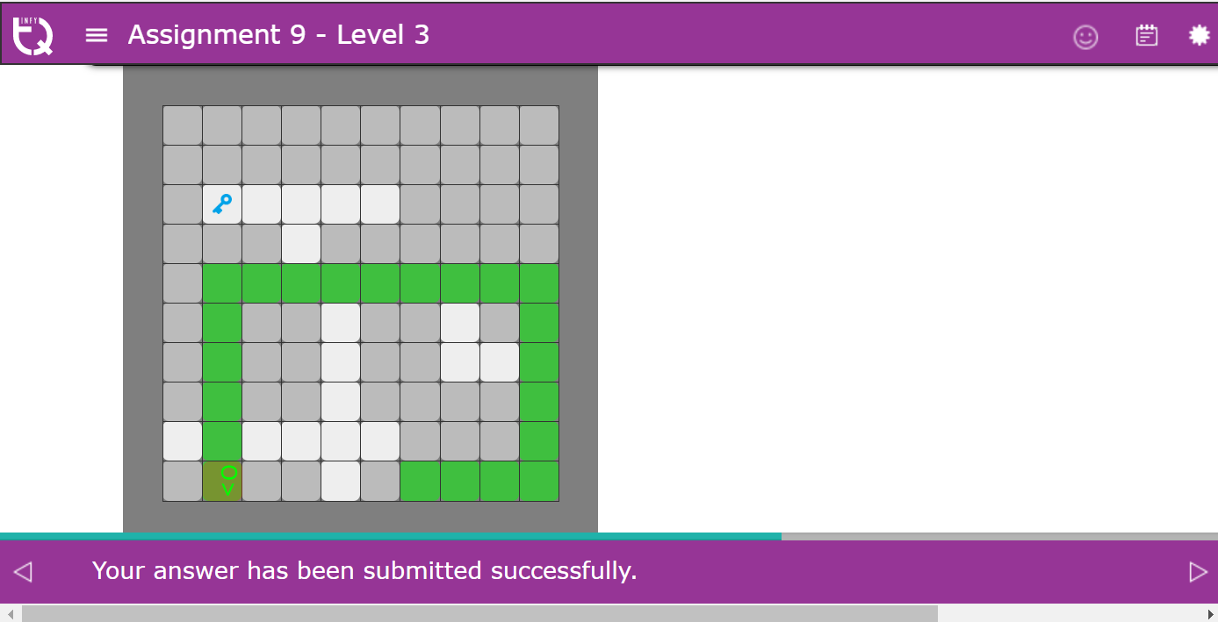

Question 10

Write a pseudo-code to recreate the figure given in the expected canvas for the scenario.  
**Note**: You can drag and drop the pseudo-code magnets to the pseudo-code step boxes and create the appropriate pseudo-code.  
**Estimated time: 20 minutes**

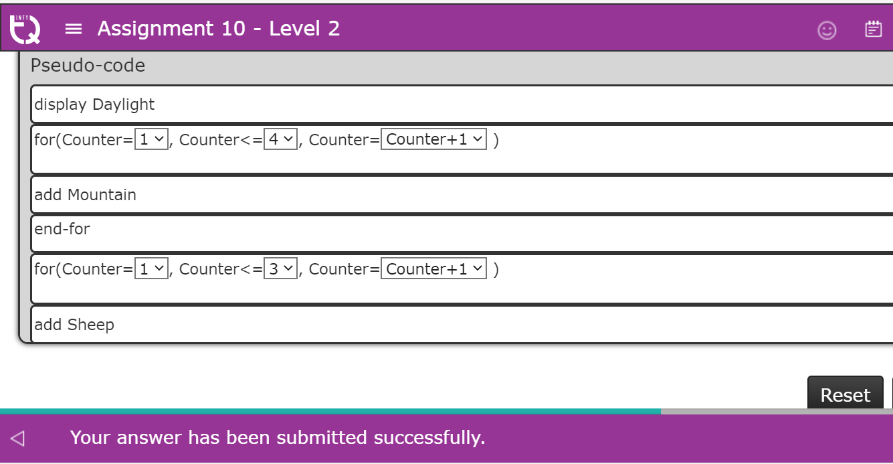

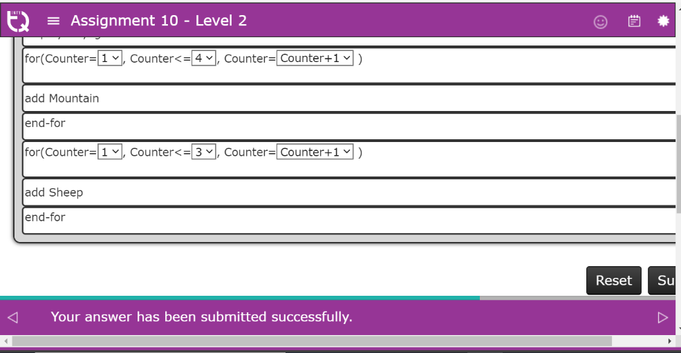

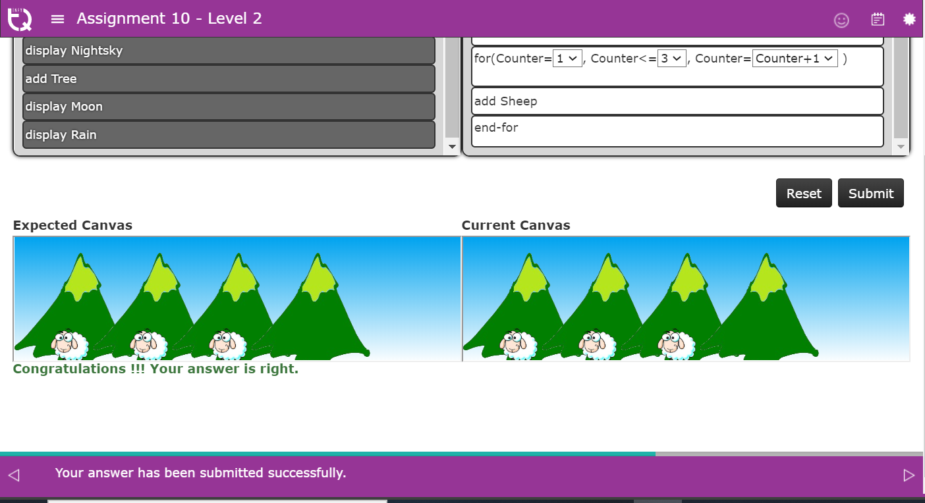

Question 11

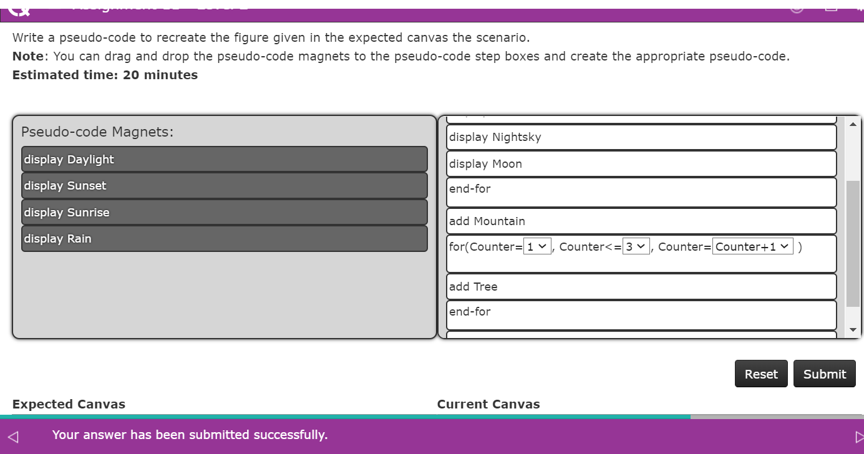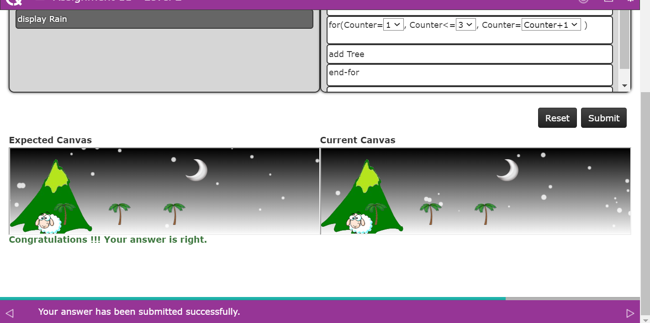

Question 12

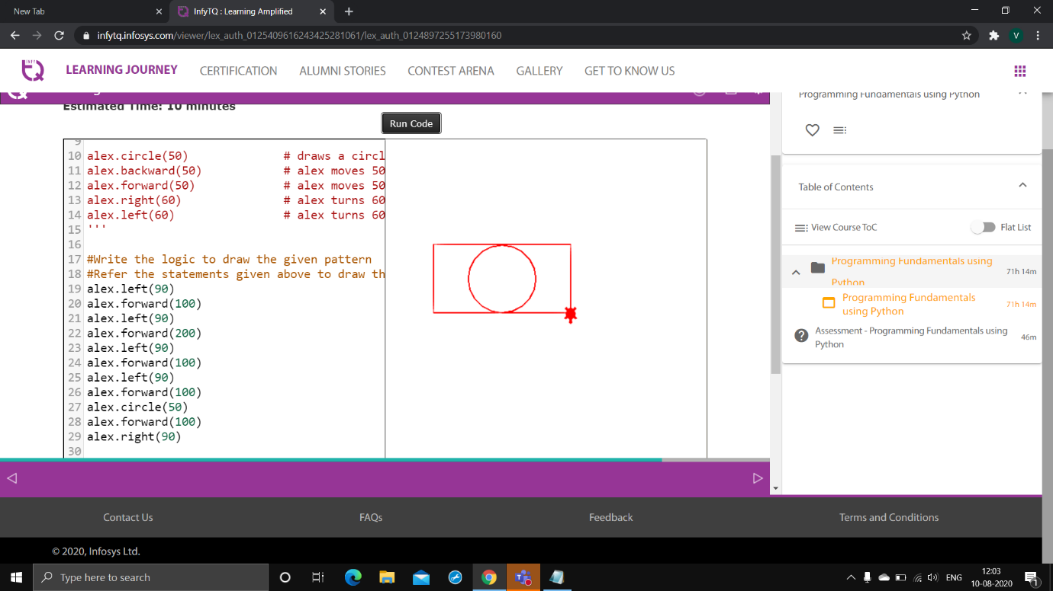

Question13

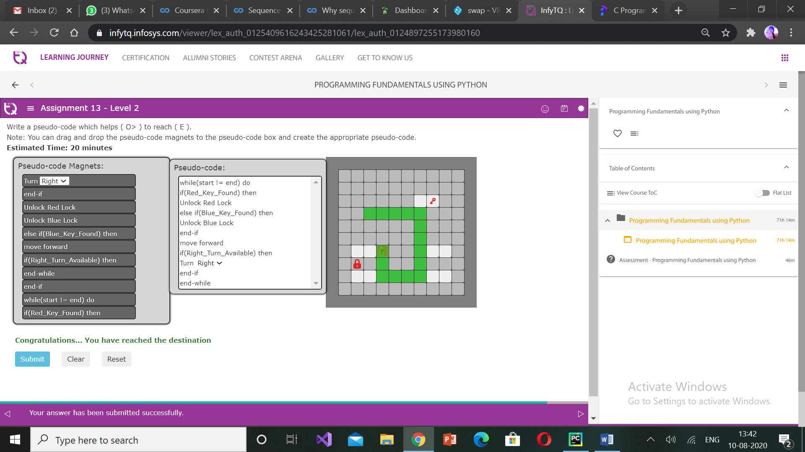

Question 14

